Dynamic Programming – Optimization Problems
0/1 Knapsack, Travelling Salesperson Problem (DP version), Optimal Binary Search Tree
Dr Gnanajeyaraman Rajaram

1. 0/1 Knapsack Problem (Dynamic Programming)

def knapsack(weights, values, capacity):
n = len(weights)
dp = [[0 for _ in range(capacity + 1)] for _ in range(n + 1)]
for i in range(1, n + 1):
for w in range(capacity + 1):
if weights[i - 1] <= w:
dp[i][w] = max(
values[i - 1] + dp[i - 1][w - weights[i - 1]],
dp[i - 1][w]
)
else:
dp[i][w] = dp[i - 1][w]
return dp[n][capacity]
weights = [1, 3, 4, 5]
values = [1, 4, 5, 7]
capacity = 7
print("Maximum Profit:", knapsack(weights, values, capacity))

Output

Maximum Profit: 9

2. Travelling Salesperson Problem (Dynamic Programming)

from functools import lru_cache

def tsp(graph):

n = len(graph)

@lru_cache(None)

def visit(mask, pos):

if mask == (1 << n) - 1:

return graph[pos][0]

ans = float('inf')

for city in range(n):

if mask & (1 << city) == 0:

ans = min(

ans,

graph[pos][city] +

visit(mask | (1 << city), city)

)

return ans

return visit(1, 0)

graph = [

[0, 10, 15, 20],

[10, 0, 35, 25],

[15, 35, 0, 30],

[20, 25, 30, 0]

]

print("Minimum Cost:", tsp(graph))

Output

Minimum Cost: 80

3. Optimal Binary Search Tree (OBST)

def optimal_bst(keys, freq):

n = len(keys)

cost = [[0 for _ in range(n)] for _ in range(n)]

for i in range(n):

cost[i][i] = freq[i]

for length in range(2, n + 1):

for i in range(n - length + 1):

j = i + length - 1

cost[i][j] = float('inf')

total_freq = sum(freq[i:j + 1])

for r in range(i, j + 1):

left = cost[i][r - 1] if r > i else 0

right = cost[r + 1][j] if r < j else 0

cost[i][j] = min(

cost[i][j],

left + right + total_freq

)

return cost[0][n - 1]

keys = [10, 20, 30]

freq = [34, 8, 50]

print("Optimal BST Cost:", optimal_bst(keys, freq))

Output

Optimal BST Cost: 142

4. 0/1 Knapsack Problem

Program

def knapsack(wt, val, W):

n = len(wt)

dp = [[0]*(W+1) for _ in range(n+1)]

for i in range(1, n+1):

for w in range(W+1):

if wt[i-1] <= w:

dp[i][w] = max(val[i-1] + dp[i-1][w-wt[i-1]],

dp[i-1][w])

else:

dp[i][w] = dp[i-1][w]

return dp[n][W]

wt = [1, 3, 4, 5]

val = [1, 4, 5, 7]

W = 7

print("Maximum Profit =", knapsack(wt, val, W))

Output

Maximum Profit = 9

5. 0/1 Knapsack Using Memoization

Program

def knapsack(W, wt, val, n, memo):

if n == 0 or W == 0:

return 0

if memo[n][W] != -1:

return memo[n][W]

if wt[n-1] <= W:

memo[n][W] = max(

val[n-1] + knapsack(W-wt[n-1], wt, val, n-1, memo),

knapsack(W, wt, val, n-1, memo)

)

else:

memo[n][W] = knapsack(W, wt, val, n-1, memo)

return memo[n][W]

wt = [1,3,4,5]

val = [1,4,5,7]

W = 7

memo = [[-1]*(W+1) for _ in range(len(wt)+1)]

print("Maximum Profit =", knapsack(W, wt, val, len(wt), memo))

Output

Maximum Profit = 9

6. Subset Sum Problem

Program

def subset_sum(arr, target):

n = len(arr)

dp = [[False]*(target+1) for _ in range(n+1)]

for i in range(n+1):

dp[i][0] = True

for i in range(1, n+1):

for j in range(1, target+1):

if arr[i-1] <= j:

dp[i][j] = dp[i-1][j] or dp[i-1][j-arr[i-1]]

else:

dp[i][j] = dp[i-1][j]

return dp[n][target]

print(subset_sum([3,34,4,12,5,2], 9))

Output

True

7. Travelling Salesperson Problem (DP Version)

Program

from functools import lru_cache

graph = [

[0,10,15,20],

[10,0,35,25],

[15,35,0,30],

[20,25,30,0]

]

n = len(graph)

@lru_cache(None)

def tsp(mask, pos):

if mask == (1<<n)-1:

return graph[pos][0]

ans = float('inf')

for city in range(n):

if not mask & (1<<city):

ans = min(ans,

graph[pos][city] +

tsp(mask | (1<<city), city))

return ans

print("Minimum Cost =", tsp(1,0))

Output

Minimum Cost = 80

8. Travelling Salesperson Using DP Table

Program

def tsp_dp(graph):

n = len(graph)

dp = [[float('inf')]*n for _ in range(1<<n)]

dp[1][0] = 0

for mask in range(1<<n):

for u in range(n):

if mask & (1<<u):

for v in range(n):

if not mask & (1<<v):

dp[mask | (1<<v)][v] = min(

dp[mask | (1<<v)][v],

dp[mask][u] + graph[u][v]

)

ans = float('inf')

for i in range(1,n):

ans = min(ans,

dp[(1<<n)-1][i] + graph[i][0])

return ans

graph = [

[0,10,15,20],

[10,0,35,25],

[15,35,0,30],

[20,25,30,0]

]

print("Minimum Cost =", tsp_dp(graph))

Output

Minimum Cost = 80

9. Optimal Binary Search Tree (OBST)

Program

def optimal_bst(freq):

n = len(freq)

cost = [[0]*n for _ in range(n)]

for i in range(n):

cost[i][i] = freq[i]

for L in range(2, n+1):

for i in range(n-L+1):

j = i+L-1

cost[i][j] = float('inf')

total = sum(freq[i:j+1])

for r in range(i, j+1):

left = cost[i][r-1] if r > i else 0

right = cost[r+1][j] if r < j else 0

cost[i][j] = min(cost[i][j],

left + right + total)

return cost[0][n-1]

print("Optimal Cost =", optimal_bst([34,8,50]))

Output

Optimal Cost = 142

10. Matrix Chain Multiplication

Program

def matrix_chain(arr):

n = len(arr)

dp = [[0]*n for _ in range(n)]

for L in range(2, n):

for i in range(1, n-L+1):

j = i+L-1

dp[i][j] = float('inf')

for k in range(i, j):

q = dp[i][k] + dp[k+1][j] + arr[i-1]*arr[k]*arr[j]

dp[i][j] = min(dp[i][j], q)

return dp[1][n-1]

print("Minimum Multiplications =", matrix_chain([10,20,30,40,30]))

Output

Minimum Multiplications = 30000

11. Coin Change (Minimum Coins)

Program

def min_coins(coins, amount):

dp = [float('inf')] * (amount+1)

dp[0] = 0

for i in range(1, amount+1):

for c in coins:

if c <= i:

dp[i] = min(dp[i], dp[i-c]+1)

return dp[amount]

print("Minimum Coins =", min_coins([1,2,5], 11))

Output

Minimum Coins = 3

12. Rod Cutting Problem

Program

def rod_cut(price, n):

dp = [0]*(n+1)

for i in range(1, n+1):

for j in range(i):

dp[i] = max(dp[i],

price[j] + dp[i-j-1])

return dp[n]

print("Maximum Revenue =", rod_cut([1,5,8,9,10,17,17,20], 8))

Output

Maximum Revenue = 22

13. Minimum Cost Path

Program

def min_cost(cost):

m = len(cost)

n = len(cost[0])

dp = [[0]*n for _ in range(m)]

dp[0][0] = cost[0][0]

for i in range(1,m):

dp[i][0] = dp[i-1][0] + cost[i][0]

for j in range(1,n)

dp[0][j] = dp[0][j-1] + cost[0][j]

for i in range(1,m):

for j in range(1,n):

dp[i][j] = cost[i][j] + min(dp[i-1][j],

dp[i][j-1])

return dp[m-1][n-1]

cost = [

[1,3,1],

[1,5,1],

[4,2,1]

]

print("Minimum Cost =", min_cost(cost))

Output

Minimum Cost = 7

1. 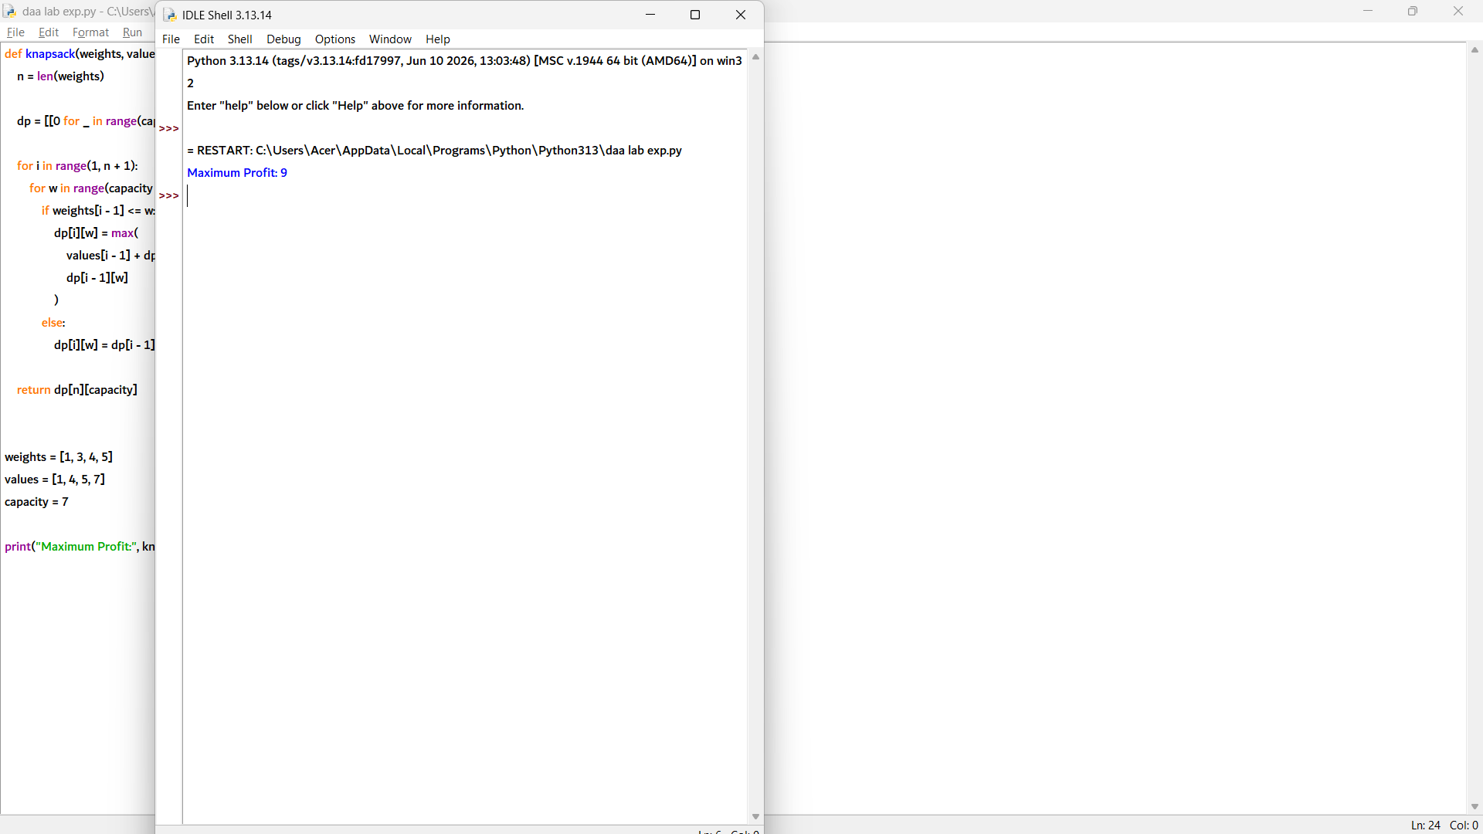

2. 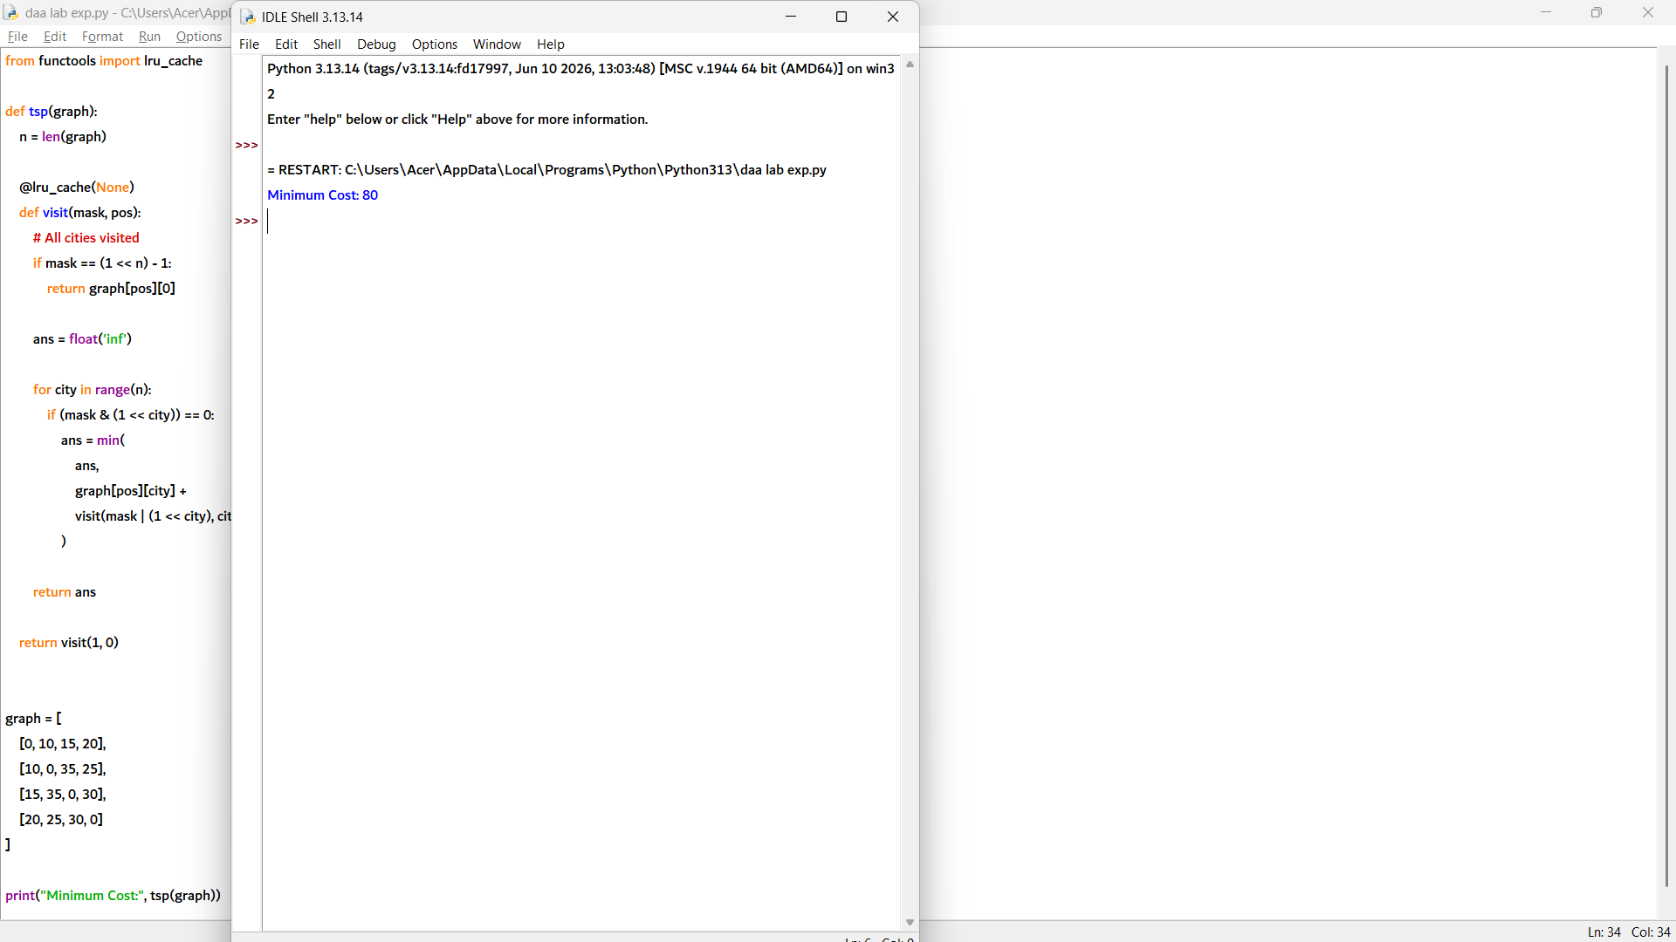

3. 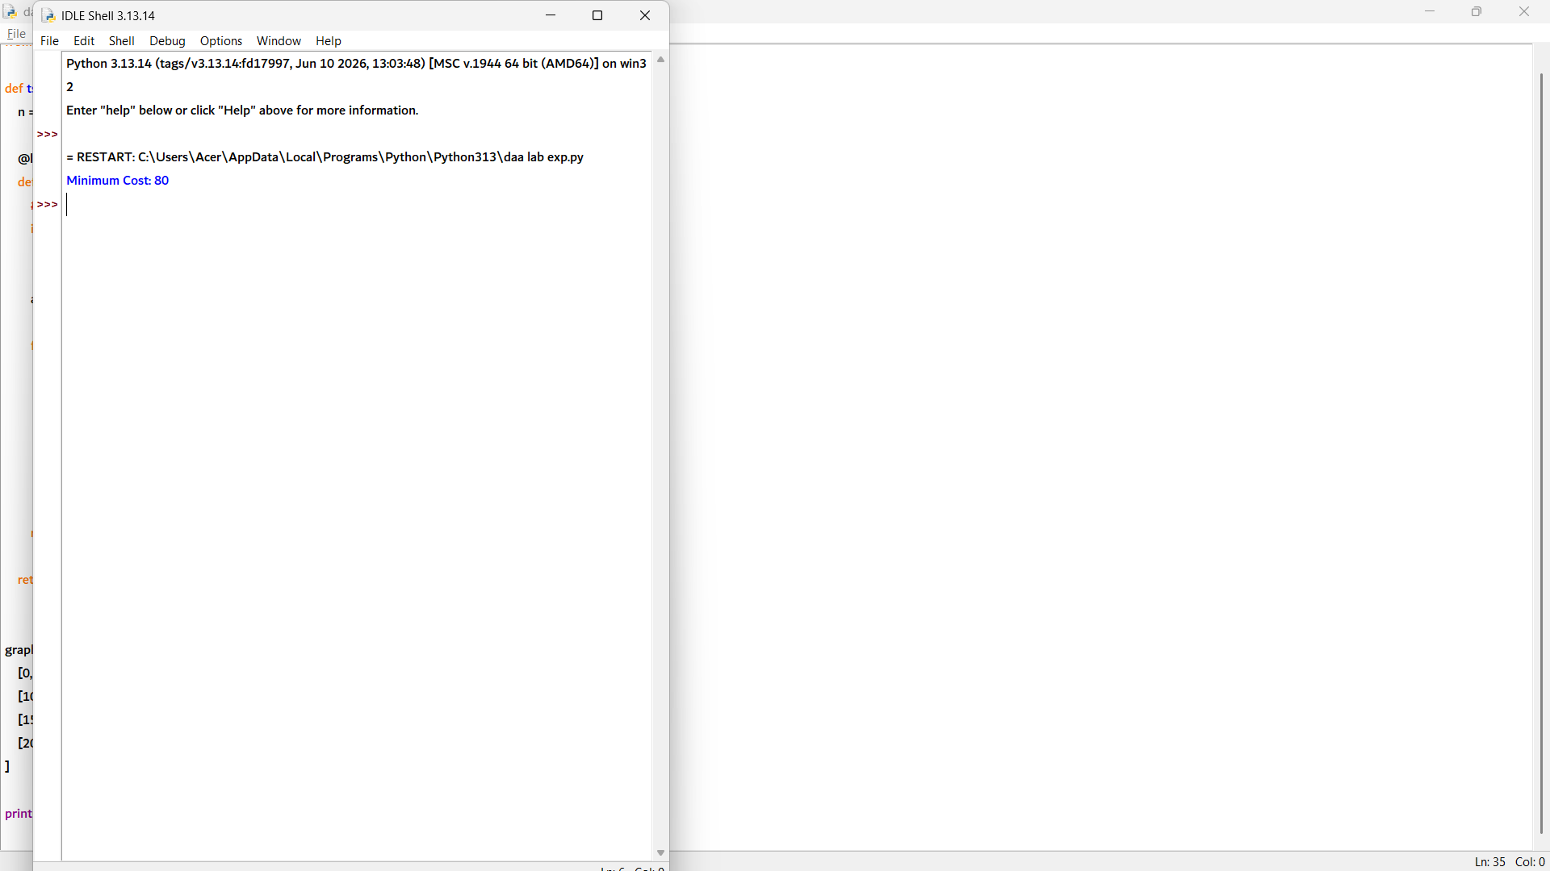

4. 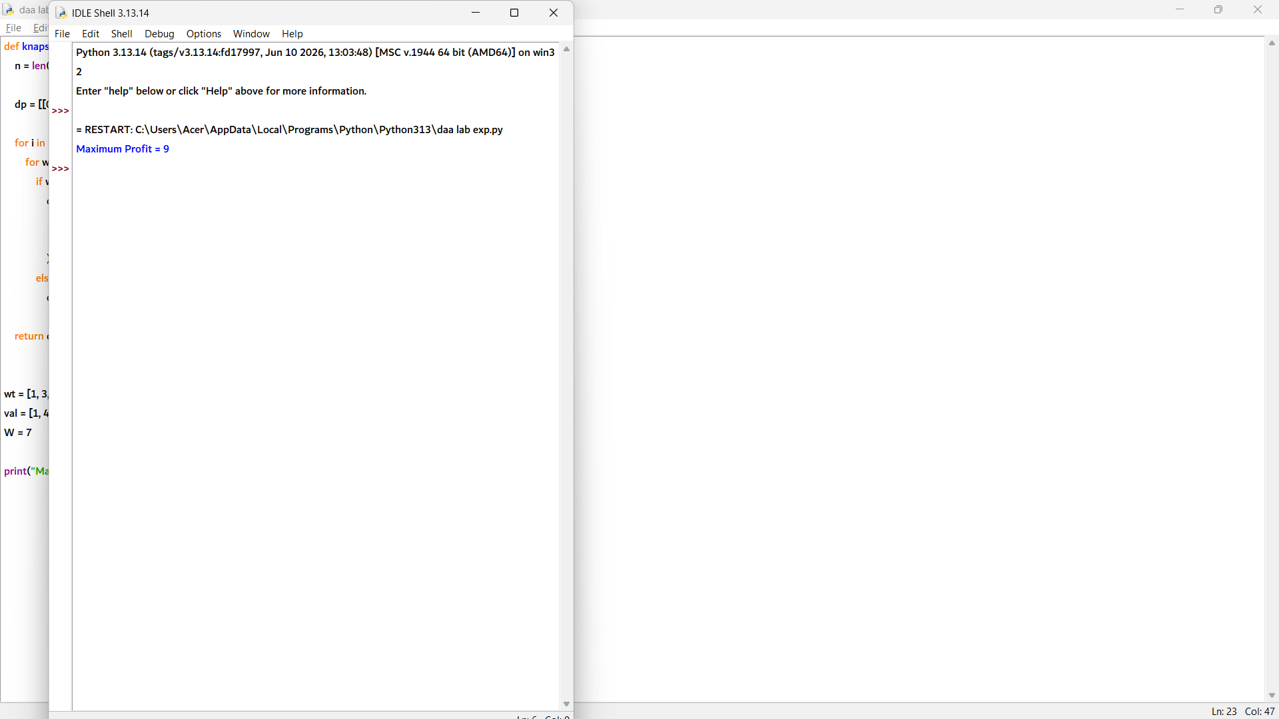

5. 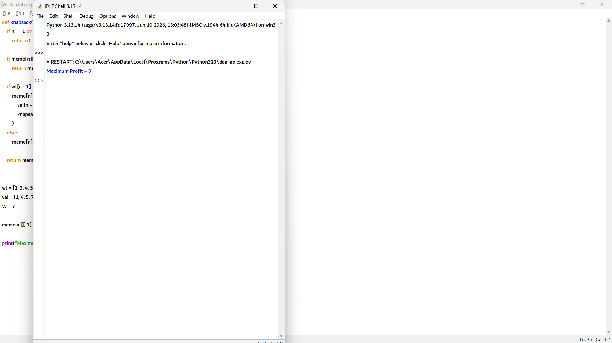

6. 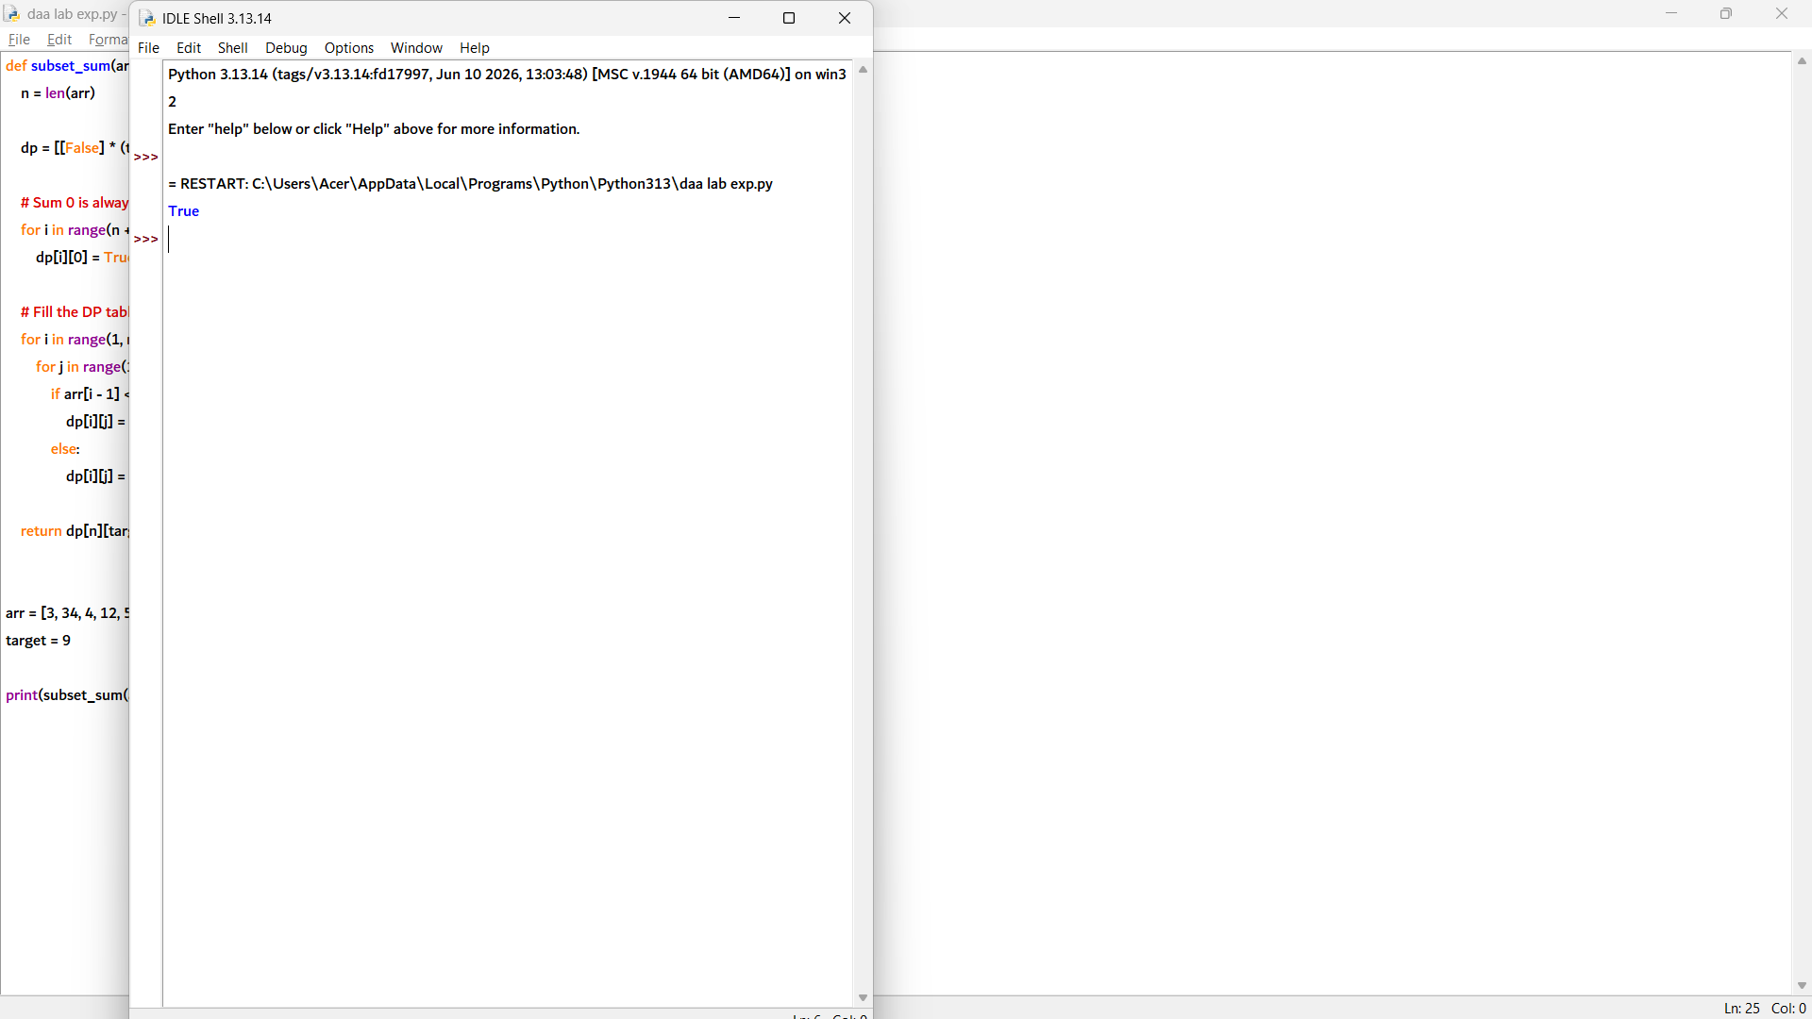

7. 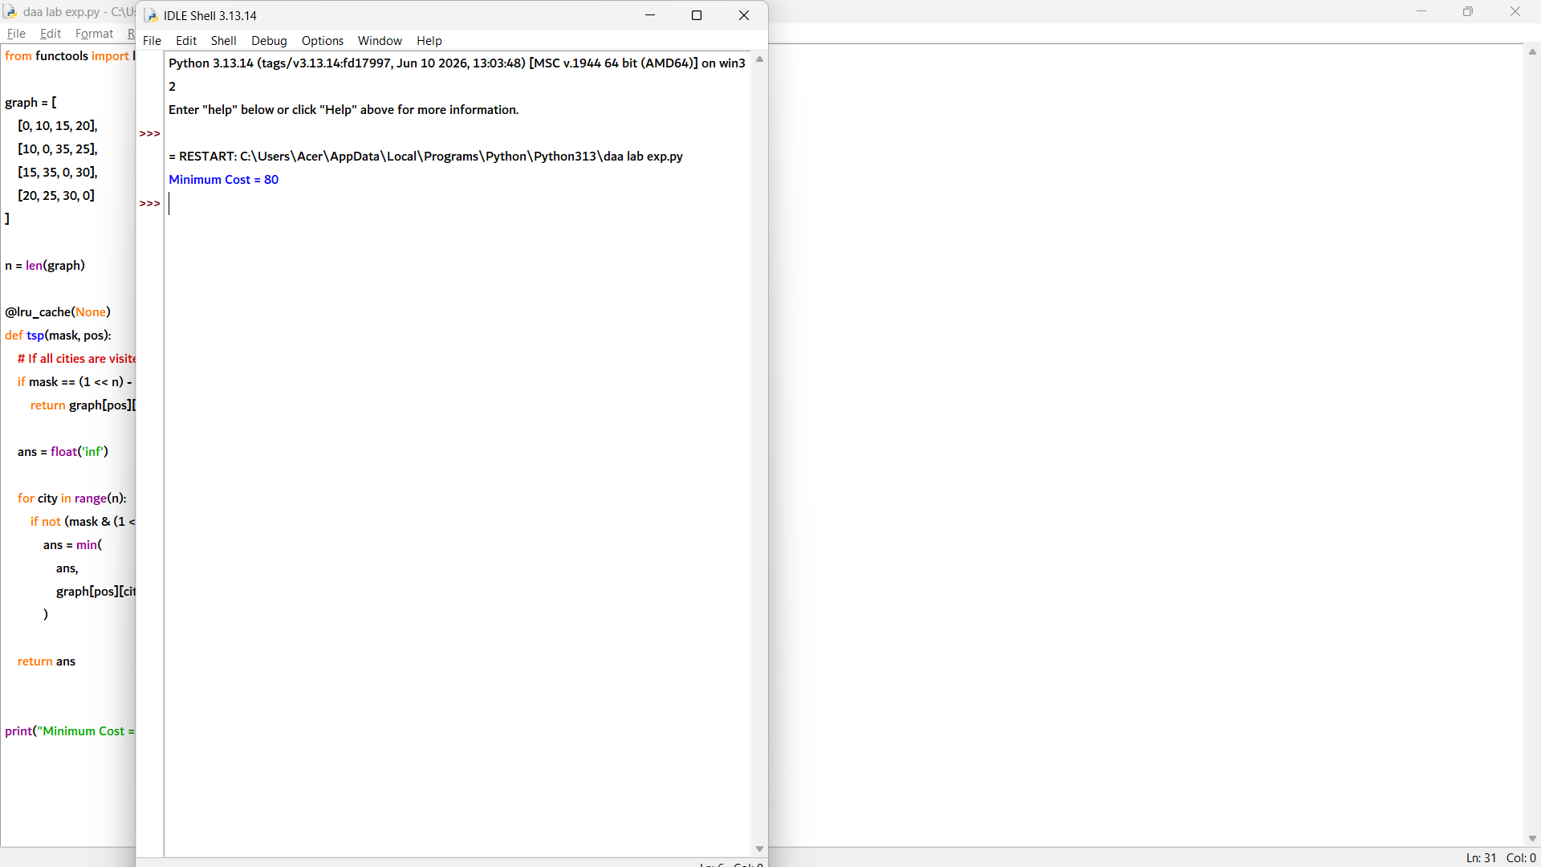

8. 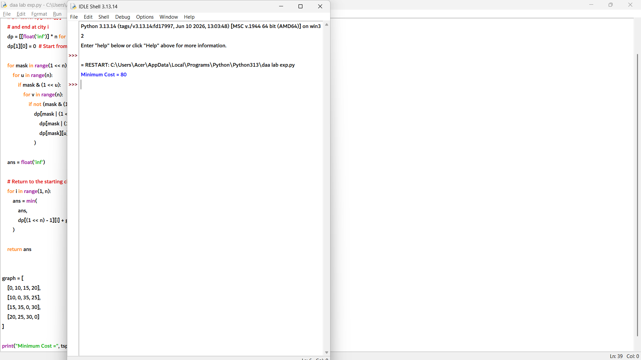

9. 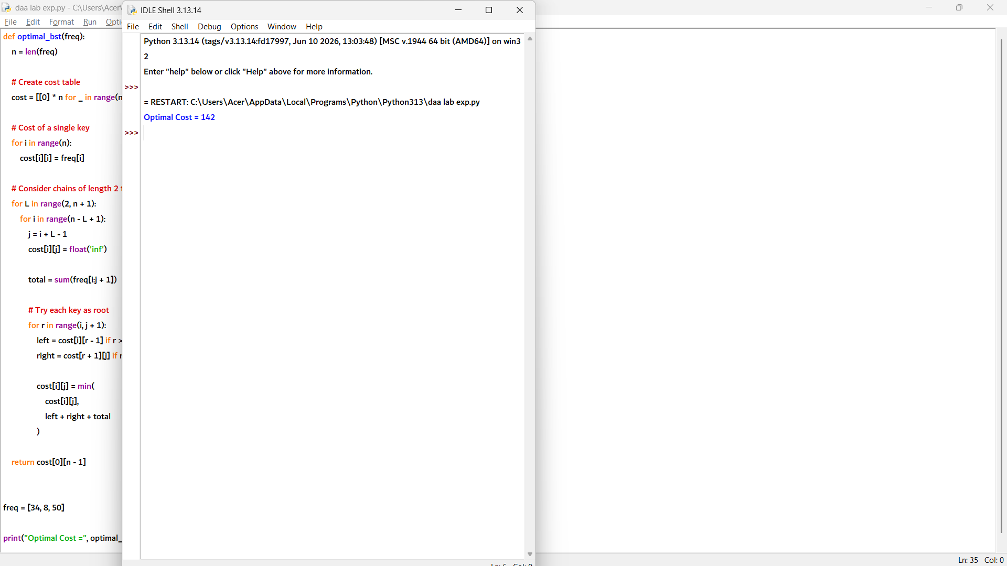

10. 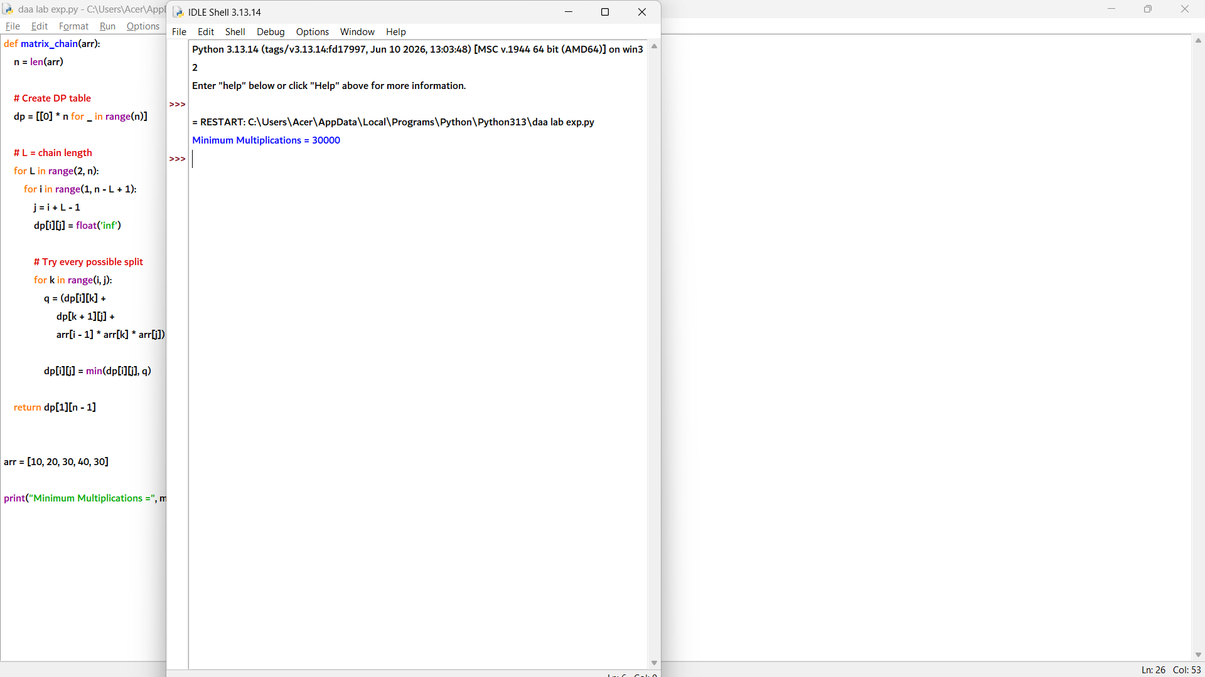

11. 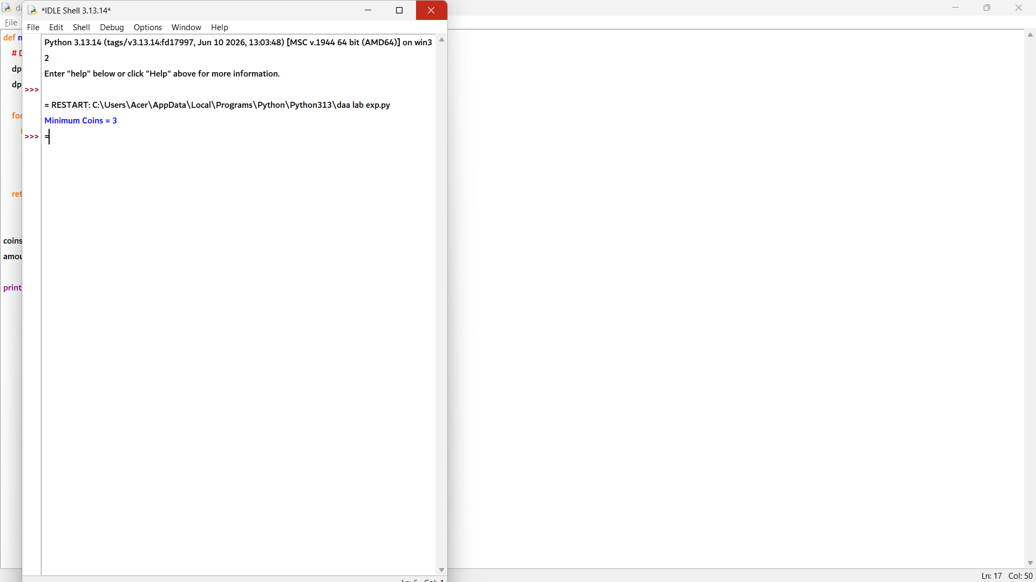

12. 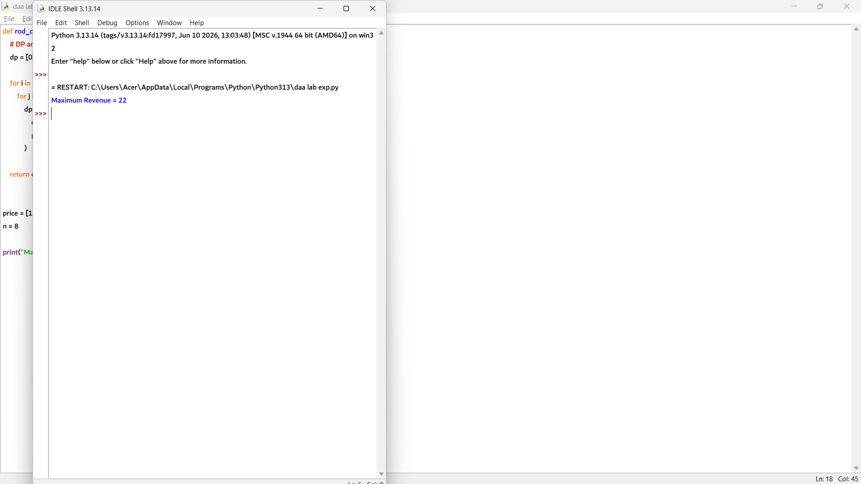

13. 